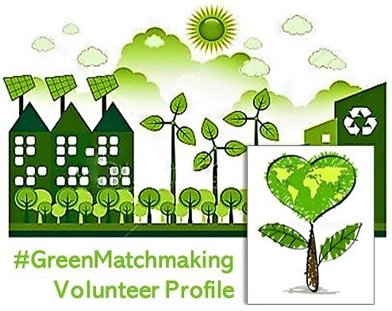

Work, learning and play: WESSA LIFE (Local Initiatives For the Environment) is aimed at revitalising and strengthening WESSA membership from the ground up by working actively with our volunteer members and supporters.
___________________________________________________

Thank you for your interest in volunteering for WESSA. Please complete the following information. Indicate the focus area(s) you would be interested in, as well as details of your skills and interests and how you might like to contribute.

DATE OF APPLICATION |  |  |  |  |  |  |  |  | TITLE
SURNAME & INITIALS |  |  |  |  |  |  |  |  | MB NUMBER
preferred first name |  |  |  |  |  | EMAIL
ID Number | date of birth |  |  |  |  |  | PHONE
POSTAL ADDRESS
 |  |  |  |  |  |  |  |  |  |  | POSTAL CODE
PHYSICAL ADDRESS | AREA WHERE BASED
NAME OF NEXT OF KIN | NAME
 | ADDRESS
 | EMAIL |  |  |  |  |  |  |  |  | PHONE
 | RELATIONSHIP TO YOU
 | VALID DRIVERS LICENCE |  |  | Y/N |  | OWN TRANSPORT |  |  |  |  | Y/N
INDICATE FOCUS AREA(S) THAT WOULD INTEREST YOU |  | Citizen science |  |  |  |  |  | Environmental governance
 |  | Community food gardens |  |  |  |  |  | Green art and creativity
 |  | Ecosystems and biodiversity |  |  |  |  |  | Green enterprise
 |  | Energy and green audits |  |  |  |  |  | Waste minimisation
 |  | Enviro education and training |  |  |  |  |  | Water protection
TELL US ABOUT YOURSELF & YOUR COMMUNITY: Occupation; talents, skills and interests; activities you enjoy; qualifications; why you want to be involved in environmental volunteerism; what are the social and environmental challenges faced by your community; any ideas | suggestions you may have for what can be done to address these issues. If you are able and would like to, please also include a photo. Continue on to another next page if required.

PHOTO

Please sign up online as either a member or free supporter by going to: www.wessalife.org.za This will generate your MB Number. Email the completed form to: membership@wessalife.org.za If available, please also include a CV and any references.

